Time Series
Student Name
Institution affiliations
Date.

1. Define the term “time series” and construct an example graph that you might use in teaching the concept to another student. What variable is on the horizontal axis of your graph? What variable is on the vertical axis in your example? What aspect of the data is most important in such a study, in contrast to traditional statistics? What aspect is less important?
A time series refers to a sequence of numerical data points indexed in successive time order. It does not have a minimum or maximum amount of time that can be added at regular intervals. For instance, to create a time-series graph of the United States population between 1960 to 2010, the student needs to take the year as the horizontal axis data and the population as the vertical axis. The graph will show a straight line that shows a steady increase in population. The most important aspect in the construction of time series is to identify the trend, seasonality, and irregularities within the data. For instance, the main aim was to determine the trend of the census analysis. The least important aspect was seasonality in terms of the baby boom seasons where irregularities in population growth may be experienced.
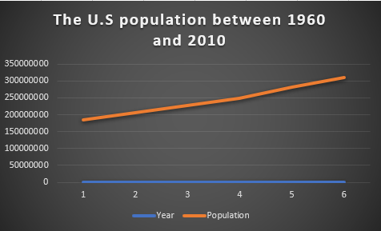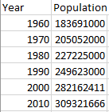
2. How does a time series design change our way of looking for evidence of an "effect" or "no effect" of treatment or another interruption event? Give a public policy example in which different opinions exist about the effectiveness of a change in the law, or a change in government, or an “interruption” in general.
Time series play an important role in determining an effective model for business forecasting by determining timely trends and patterns. However, the availability of an interruption event represents the point where intervention was implemented when there was no possibility of randomization. An example of a public policy is economic affairs policies that ensure the availability of laws, actions, and regulations that reflect given budget and taxation laws of a specific business organization. For example, the issue of gun possession requires a public policy. That is, tougher laws ensure public policies that lower crime and economic benefits of gun manufacturing business while enacting looser gun laws is based on the public policy that prioritizes the rights of gun owners which therefore increases gun violence.
3. Why would you warn a public official not to simply average data over several years in evaluating the impact of a law?
Evaluating the impact of laws on public policies is a very complex process. Therefore, averaging data is not an effective option since it leads to the fabrication of data that may mislead the public. Moreover, important resources such as time and finances may be wasted on results that may not be accurate. For instance, interruptions may occur that may cause interruptions and alter the credibility of the data. Furthermore, averaging leads to unfair results that the public may not be comfortable with.
4. Select some archived time series data from the internet. Browse it and understand what it is about. Construct a graph of a portion of this data, focusing on an aspect of it that interests you. Write a paragraph about this exploratory exercise.
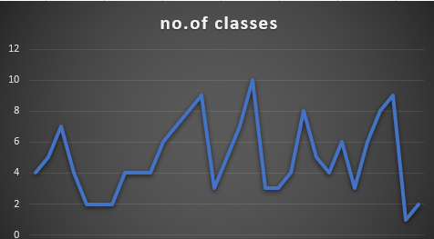
The above data series from the UCR time series archive shows a random variation. Random variation lacks patterns or cycles. The magnitude of the variations is not constant, showing that the seasonal changes are multiplicative. A multiplicative seasonal change makes it harder to forecast the data accurately. Moreover, it shows a cyclic movement that does not repeat itself at a regular interval and does not show the same shape.
5. Do the same thing with an archived data set that is not a time series.
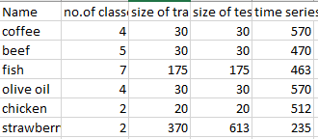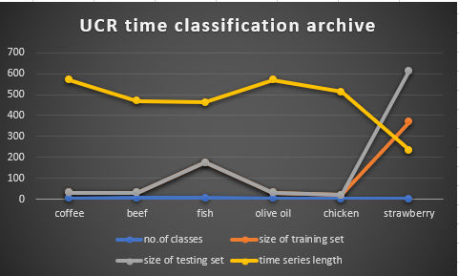

From the same URC data series classification archive, I compare six elements, that is, coffee, beef, fish, olive oil, chicken, and strawberry in terms of the number of classes, the size of the testing set, the size of the training set and the length of the time series. The graph shows that there is an unclear trend. That is, there is a slight curve in the data, both upwards and downwards for most elements. However, sudden shifts in the series require that the trend be looked at.

